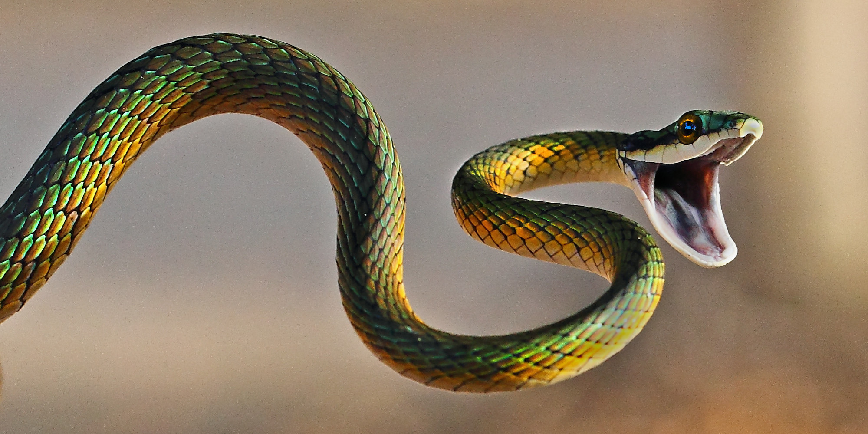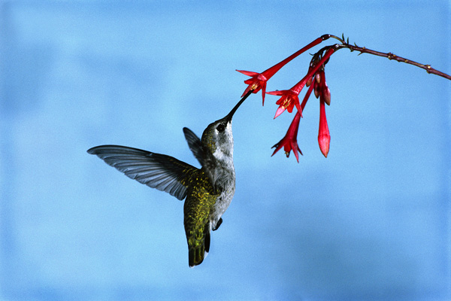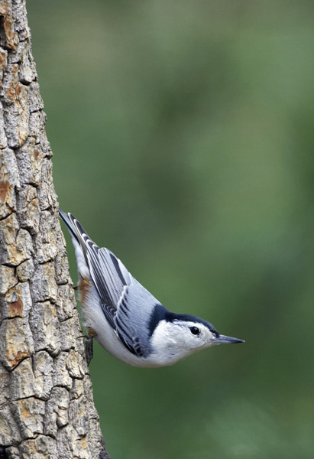

**How to contact Ms. Cook:**

Email: lecook@dcsdk12.org

Before school: VPA office

Advisement: Room 8100

1. **Nature of Science and Characteristics of Life:** We will learn about the science process through lab activities and learn about the qualities that all kinds of life share.
2. **Biomolecules:** We will explore the structure of the matter that make sup life and learn how various molecules are used and effect our nutrition.
3. **Cells and Energy:** Students will learn about cell structure and types as well as discover how they obtain and use energy.
4. **Genetics and Reproduction:** Students will learn patterns of inheritance as well as how and why cells divide in various parts of the life cycle.
5. **DNA and Protein Synthesis:** Students will explore the structure of our genetic information and learn how it codes for traits.
6. **Evolution:** We will look at evidence and patterns of evolution to understand and appreciate the diversity of life on earth.
7. **Ecology**: Students will explore how organisms interact with their environment and each other to sustain life on earth.

Making Connections

Students will be able to reflect critically on their learning and growth in order for them to more effectively develop learning skills.

Self- Reflection

Students will be able to connect topics from different parts of the class and from outside of class to better understand.

Students will design experiments, develop questions and draw critical conclusions.

Scientific Thinking

Students will create graphs and use mathematics to analyze data.

Mathematics and Graphing

Students will use models and experimentation to investigate and analyze concepts.

Investigations

## Science Skills

# Topics

Biology

pg. 3

www.cookbiology.weebly.com

lecook@dcsdk12.org

#### Grading Policies

Any questions I can help answer? ____________________________________________________________________________________________________________

I (student printed name) have read and understand what is expected of me as a biology student. I have reviewed this with my parent/guardian.

________________________________________________ ___________________________________________ ____________

Student Signature Parent/Guardian Signature Date

**Retakes**

* Students can retake tests and quizzes if it is taken care of in a reasonable time, usually about a week after the test is returned.
* Students will need to complete test corrections and additional studying in order to earn the privilege to retake.

**Bathroom**

* By high school, you should have a good idea of how using the bathroom works. Try to choose a moment that will not disrupt your learning.
* You should sign out or check with Ms. Cook before leaving.
* Excessively long bathroom breaks or unusually frequent breaks will result in the loss of bathroom privileges.

1. 1-2in. Three Ring Binder
2. 6 Binder Tabs:
3. Loose-leaf Paper
4. Writing Utensils

Grades for this course will be based upon a letter written by students to Ms. Cook requesting a grade based on their understanding, growth and skill development in class. Through a discussion with Ms. Cook about work, learning and behavior, a final grade will be agreed upon at the end of the course. Feedback will be provided throughout the class through Infinite Campus. The grade on Infinite Campus will be based upon the following categories:

* Content: Quizzes and projects
* Learning Habits: Classwork, and reflections
* Scientific Thinking: Lab Reports and lab-based projects

## Supplies

**End of Class**

* I expect 85 minutes of attention and work. Packing up and not working at the end of class will result in you being held after the bell.

**Make Up Work**

* Students are responsible for making up missed work from *all* absences as soon as possible.
* All assignments and classwork will be posted and available on the class website: cookbiology.weebly.com
* Ms. Cook will be available to help make up missed quizzes and answer questions about missed work in travel Advisement

**Homework**

* Homework will not be given frequently in biology if students are adequately productive in class.
* Any homework assignments will be communicated clearly and are expected to be turned in on time in order to ensure all students are prepared for class and understand important material.

**Cell Phones**

* Cell phones are a frequent distraction from learning and should remain in backpacks during class unless you have permission to use it for an educational purpose.
* Students misusing cell phones will have them taken away or will be referred to a dean.



# Policies