Title: Mythbusters: What is the Effect of Gender on Driving Abilities?

Introduction:
The purpose of this lab is to test the social controversy of what gender is superior at driving, male or female. This will be an important test in order to bring scientific results to popular opinions.
According to WebMD, women tend to have a more developed corpus callosum, which is associated with language and emotional proficiency. Men, however, have larger temporal lobes, which may help them with spatial awareness. Overall, there is much overlap in the abilities of men and women. For example, many women excel at spatial tasks and many men are emotionally aware. Scientists believe that more individual differences may be attributed to the way people are brought up rather than their gender alone.

Hypothesis:
Men will perform better in a driving skill test driving because men will likely be better at tasks involving spatial reasoning such as navigating, driving and packing because they tend to have larger temporal lobes.

Experimental Design:
Materials:
- Car
- Driving course
- Driving instructor
- Disguises
- Stopwatch
- Cones
- Speed monitor

Procedure:
Twenty male and female volunteers were selected on the basis that they have at least five years of driving experience and were not professional drivers. Volunteers were given a map of the course and clear directions on rules and scoring.
The volunteers were then disguised using heavy jackets, goggles, gloves, balaclavas, and false breasts (for the men) so that the gender was not apparent to the driving instructor. All drivers were asked to complete a driving course within seven minutes and to stay below 25 miles per hour. Points were deducted from a starting score of 100 for mistakes, hitting cones and speeding.
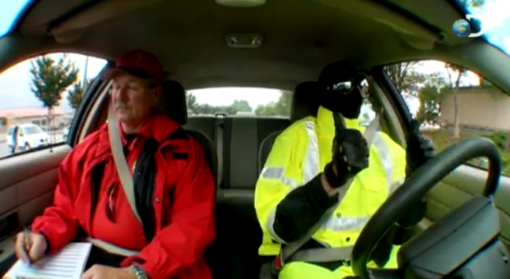
After the trials, scores for each gender were averaged and compared in the areas of total driving score and speeding.

Above: gender disguise

Variables:
Independent Variable: Gender
Dependent Variable: Driving Skill
Control: Perfect score on driving test
Constants: Appearance of drivers to instructor, driving course, vehicle, driving instructor, instructions, speed limit

Data:
Quantitative Driving Test Results
Test | Men | Women | Difference | Busted or Confirmed
Average Driving Score (out of 100) | 79 | 71 | 8 | Confirmed

Qualitative Observations
Both male and female groups had both very poor and very good drivers. Male drivers more frequently were deducted for mistakes on the parallel parking and Y-turn portions of the course and females were more frequently deducted for speeding and the slalom back portion of the course.
Before the trials, men were observed to be more confident in their abilities while females were typically more modest.

Conclusion:
The hypothesis for this experiment was supported on the driving. In general, men performed better on the driving test and averaged 8 points higher than female participants.
The difference in the temporal lobes of men and women may be responsible for these differences since the men have larger temporal lobes, generally making them better suited for tasks involving spatial reasoning such as driving. It is likely, however that much of the difference in driving ability can be attributed to cultural rather than biological differences between males and females. In this experiment, several females performed batter than the male average and one male performed far below the female average. This supports the idea that cultural differences are at play because there is much variation between individuals, suggesting that both genders are capable of being very good or very bad drivers but that skill is more directly related to driving instruction and experience. It is likely that men spend more time driving and attribute more value to their ability to drive because of common stereotypes. The level of male confidence observed before the trials also supports this conclusion.
Even though the Mythbusters are professionals, there were a few potential sources of error in this experiment. First, they tested some of the driving test participants when it was raining, and some of the participants when it was not. This could affect the results because it would be much harder to navigate and do maneuvers in a car on wet pavement compared to dry pavement. The results of the dry pavement participants would most likely be higher than the wet pavement participants. Another possible source of error was that some of the participants were tested in the morning, and some of the participants in the evening. Because of temperature increases as the day goes on, the tires on the car would be more inflated at noon than they would be at eight in the morning. It would be better to be driving on more inflated tires at noon, therefore the later the participant went in the testing, their results may have been higher due to this variable. Overall, the results of this experiment can be seen as valid because about the same number of male and female participants were tested in adverse conditions but a larger sample of participants would help reduce the possibility of these errors being significant.
If this test were to be repeated, it would be better to do it in an indoor location to account for weather, and to have a constant temperature. A larger sample would also help reduce the effect of any errors.

Citations:

"How Male and Female Brains Differ." WebMD. WebMD. Web. 8 Jan. 2015. <http://www.webmd.com/balance/features/how-male-female-brains-differ>.

