Chi-Square (χ²) Statistical Analysis Tutorial

Overview
How close is close enough? How can you determine whether or not a set of data is close to what you expected? In Biology, and statistics in general, a Chi-Square Analysis is typically done to determine this to a given confidence level. Our threshold for error is 5%, meaning that we are willing to say that if our outcome is within ±5% of what we expect it to be, we assume it is close enough, and that any observed difference is due to random error or chance. If this is the case, and we would receive a p-value ≥ 0.05 (probability ≥ 5%), and would fail to reject the null hypothesis (H₀) while rejecting the alternative hypothesis (H_{a}). This is because we would expect to see results close to the expected (H₀) ≥ 5% of the time.
In order to conclude that a set of data is different than what we expect, we must determine whether or not that difference is statistically significant when compared to H₀. To do this, we would expect to see a p-value ≤ 0.05, indicating that results comparable to what we would expect (using H₀) would only be seen ≤ 5% of the time, and those would be due to random error or chance.

Calculating Chi-Square (χ²) Critical Values
To determine a p-value, allowing us to reject or fail to reject the H0 and Ha, we must calculate χ² Critical Values and use a Chi-Square Table. Calculating χ² is straight-forward and should remind you of calculating % Error in Chemistry.
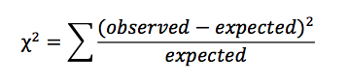

What you are calculating is % Error, but squaring the top term (o-e) so it’s always positive. The larger your χ² Value, the larger the difference between your observed and expected. Smaller χ² Values indicate a smaller difference between observed and expected. Therefore, the magnitude of this χ²Value is used to determine whether or not this difference is statistically significant.

Determine degrees of freedom (df)
This is a way to represent how many things are being measured in an experiment. It is calculated as n-1, where n is the number of experimental classes being studied. For instance, if the pillbug guided inquiry experiment is completed while looking at two events, there are 2 experimental classes (wet & dry), so 2 - 1 = 1 degree of freedom. If an experiment took place where there were only 4 possible outcomes, there would be 3 degrees of freedom.
To put it another way, if I have four numbers in my data set, which totals 10, and three of the numbers are 3, 4, 2, the last number must be 1. There is no freedom to what that last number can possibly be.

Determining p-value
Finally, we have a χ² Critical Value and the degrees of freedom for the experiment. Putting these together, using a Chi-Square Table, we can determine our experimental p-value. This will ultimately let us reject, or fail-to-reject, our H₀ and H_{a}.

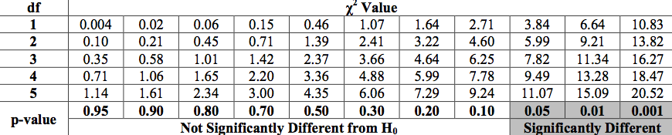

You should notice that the more degrees of freedom in an experiment (i.e., the more things being measured) means that the χ² Value needs to be larger in order to be significant. This is because as more measurements are made, more random error and chance will be encountered.

How To Put It All Together
You’ll want to make a table similar to this, using the pill bug guided inquiry experiment as an example:

Event | # observed | # expected | (o – e) | (o – e)² | (o – e)²  e
wet
dry
x² = Σ (o – e)² / e |  |  |  |  | x²=
Do you reject or fail to reject your H₀?

Example Problem
An experiment is performed to determine whether mouse habitat preference is dependent on the color of their coat versus the color of the earth. The experimental setup included a small plot of land containing 50% tan and 50% black earth. Researchers observed the different color mice over a period of 2 hours and measured the length of time they spent on each color backdrop.

H₀:

H_{a}:

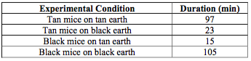
Here is the data the group compiled, after observing multiple mice over a period of 2 hours:

χ² Value:_________ degrees of freedom: _________ p-value: _________

Conclusion: (reject/fail-to-reject H₀ & state a general conclusion with regard to the experimental findings)

