BACTERIA
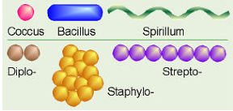
- Common shapes
  - Cocci (round)
    - Streptococcus
    - Staphlylococcus
  - Bacilli (rod-shaped) ex. E. coli, Salmonella
  - Spirilla- helical
- Cell Walls
  - Peptidoglycans- polymer of sugars and amino acids
  - Gram-Positive (absorbs and retains crystal violet stain Purple)
    - Thick peptidoglycan layer
    - Staphylococcus, Listeria, Clostridium
  - Gram-negative (does not absorb crystal violet Pinkish)
    - Thin peptidoglycan layer
    - E. coli, Yersinia pestis, Neisseria gonorrhoeae, Neisseria meningitides
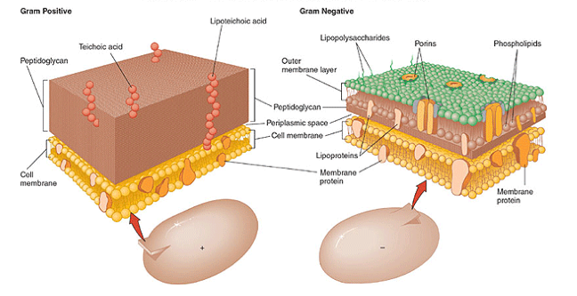
    - Often associated with hospital-acquired infections
  - Antibiotic treatment depends on type (works on cell walls)
- Reproduction
  - Binary fission- cell grows, replicates DNA and splits
  - Budding- new individual develops as bud from parent
  - No sexual reproduction- so how do you exchange genetic info?
    - Conjugation (horizontal gene transfer)
      - Through tube called pilus
      - Exchange plasmids (small DNA portions)
- Plasmids
  - Can exist independently from bacterial chromosome
  - Small, circular portion of DNA
  - Usually is adaptive for bacteria
  - F plasmid
    - F+ can transfer to F-
    - F=Fertility
    - Passed to daughter cells
  - R Plasmids
    - Resistance to antibiotics
    - Can transfer resistance to different species of bacteria (more pathogens!)
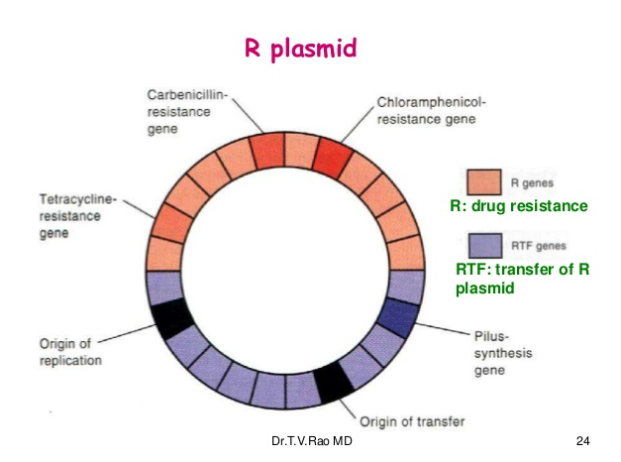
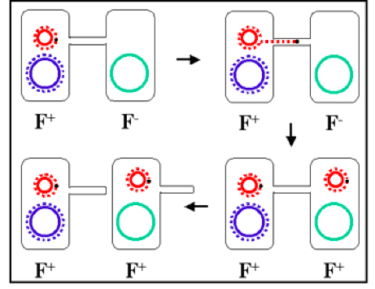

- Antibiotics
  - Difficult to manufacture because they need to specifically target bacterial cells but not harm your own cells.
  - Penicillin- originally discovered through mold growing on bacterial plates (Alexander Fleming)
  - Have greatly reduced the number of deadly infections in humans (tuberculosis, surgery infections)
  - Types
    - Weaken cell wall
    - Weaken cell membrane
    - Interfere with bacterial enzymes
  - Resistance
    - All antibiotic classes used today were discovered prior to the mid 80’s
    - Bacteria with random mutations that cause resistance to antibiotics are able to survive and reproduce while those without selected against
    - We are essentially selecting for bacteria that do not respond to antibiotics
    - Misuse
      - Against viruses
      - Prophylactic
      - Failure to finish prescribed dose
      - Food animals to prevent infections
    - Superbugs
      - Resistant to many types of antibiotics
      - Thought to form is hospital settings where resistant strains come together
      - Makes treatment nearly impossible
      - Multi Drug Resistant TB, Methicillin Resistant Staph Aureus
      - ‘Post Antibiotic Era’?

