Animal Behavior – Pill Bugs Name:_____________________________
AP Biology Investigation Group Members:_______________________________________

Part One: Guided Inquiry

Question: What is a pill bug? Do pill bugs have a preference for wet or dry environments?

Materials: 10 pill bugs, dual-chamber apparatus, filter paper, tape, magnifier

Procedure:
- Obtain 10 pill bugs from the stock container.
- Place pill bugs into a glass beaker for observation.
- Observe their natural behavior for a couple minutes. Describe your observations:

- Perform a detailed sketch of a pill bug below:

- Test the pill bugs behavior to wet or dry climates. To do this, gather a dual-chamber apparatus from the materials desk. Label (with tape/paper!) one side ‘wet’ and one side ‘dry’.
- Cut a piece of filter paper to fit into the ‘wet’ side of the chamber. Tape this piece down as much a possible to prevent pill bugs from crawling underneath the paper.
- Moisten the filter paper. (Note: So the filter paper is wet but not dripping. We do not want to drown the pill bugs.)
- At this point, the ‘wet’ side of your chamber should have moistened filter paper and the ‘dry’ should be completely dry.
- Before you add the pill bugs, create a general hypothesis and a null hypothesis. A general hypothesis is stated in an “if, then, because” statement. The hypothesis you create should be linked to the wet/dry experiment you are setting up and express what you think will happen.
Hypothesis (H_{A}):

The null hypothesis, on the other hand, is the control or default position on an experiment. For example, the null hypothesis might be that there is no relationship between two measured phenomena or that a potential treatment has no effect on the object. The null hypothesis does not need to be in an “if, then, because” statement.
Null Hypothesis (H₀):

It’s important to note that scientists never prove a hypothesis. We simply reject or fail to reject our null hypothesis. For example, if comparison of two groups (e.g.: treatment, no treatment) reveals no significant difference between the two, it does not mean that there is no difference in reality. It only means that there is not enough evidence to reject the null hypothesis (in other words, the experiment fails to reject the null hypothesis). At the end of this guided inquiry, we will either fail to reject that there is no preference for wet or dry environments or reject that there is no preference for wet or dry environments.

- Of your original 10 pillbugs, place 5 into the ‘wet’ chamber and 5 into the ‘dry’ chamber. Every minute for 10 minutes, count the number of pillbugs in each chamber. Record any observations you see at those separate time periods as well.
- Calculate the average number of pill bugs in each chamber in the 10-minutes time period.
- Place your average number on the board and record the class data on your data sheet as well.
- Once the data is collected, you must analyze that data and decide if you results either accept or reject your null hypothesis (H₀). When analyzing data, you must determine whether or not a set of data is close to what you expected. To do this in biology, you need to perform a Chi-Square Analysis. Do this for your group’s data AND the class data.

Data:

Group Wet vs. Dry Investigation
Time  (Minutes) | Amount of pill bugs in “WET” chamber | Amount of pill bugs in “DRY” chamber | Overall Observations
0
1
2
3
4
5
6
7
8
9
10
GROUP  AVG: |  |  | Record the average number of pill bugs in each chamber for your group in the grey boxes to the left.

Class Averages:
Group Number | Average Amount of pill bugs in “WET” chamber | Average Amount of pill bugs in “DRY” chamber
CLASS TOTAL:

Chi-Square Analysis of Group Data: Use p-value of 0.05, d.f. = 1, CV (critical value) = 3.84
Event | Observed (o) | Expected  (e) | o – e | (o – e)² | (o – e)²  e
wet
dry
x² = Σ (o – e)² / e |  |  |  |  | Add both and place total here:  x²=

Chi-Square Analysis of Class Data: Use p-value of 0.05, d.f. = 1, CV (critical value) = 3.84
Event | Observed (o) | Expected  (e) | o – e | (o – e)² | (o – e)²  e
wet
dry
x² = Σ (o – e)² / e |  |  |  |  | Add both and place total here:  x²=
** Reminder: If your x² value is bigger than the critical value then reject your H₀. If your x² value is smaller than your critical value then fail to reject your H₀.

Critical Value Charts: (Many different versions of this chart but they all have the same data!)

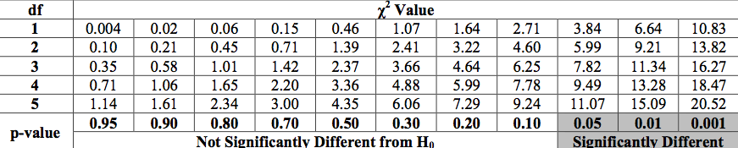

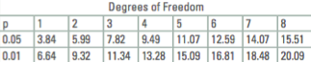
Data Summary: Write a short paragraph explaining the results you got below.

Analysis/Conclusion:
How does your results connect to your hypotheses? (Fail to Reject/Reject Null Hypothesis? Why?)

Why did you use a chi-square analysis on this experiment?

Why do you think you got the results you did? (Might need to do some outside research for this. Cite your resources!)

What were some experimental errors that occurred AND how could they have affected the experiment?

What additional questions did this lab generate? What other things might pill bugs have a preference for?

Part Two: Open Inquiry

Take the questions you came up with in the analysis/conclusion section and, as a group, pick one that interests you all the most. You will be creating your own experiment to answer that question. The only main restriction is you cannot put the pill bugs in any immediate physical danger. (AKA – can’t light them on fire, can’t drown them, can’t eat them, etc.)

Requirements:

Before you begin the investigation you will need the following details sorted out:

- What’s the question you are asking?
- What is your hypothesis & null hypothesis?
- What is your procedure?
- How will you keep your data organized?

You will be writing a formal lab report on this investigation. Please note that you do not need to include any information/data from the guided inquiry part. The lab report will only have your own investigation information & data. Please see the “AP Biology Lab Report Guidelines” sheet to help you with the format and required sections.

